Eight Weeks that Will Change Your Life.

As a graduate of Job’s for Life, in just eight weeks you will….
- Be able to speak more confidently in front of a group.
- Have a professional resume you will be proud of.
- Meet with local employers and learn what they look for when hiring.
- Be prepared and confident in job interviews.
- Have a clearer picture of what you want in life.
- Feel better about who you are and where you are going.
- Have a deeper faith in yourself and God’s plan for you.

Classes Meet Tues/Thurs, 6-8pm
Sept 25th to Nov 15th 2018
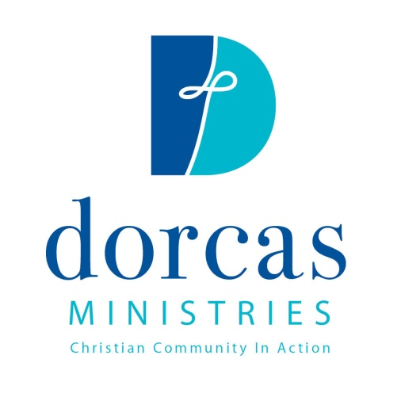
Ready to apply?
Get an application from: dorcas-cary.org
or in the Crisis Ministry, 187 High House Rd, Cary Plaza
Need more info?
Give us a call : 919.469.9861, ext. 201
or email: outreach@dorcas-cary.org

